# Smartphone founder

The **smartphone** as we know it today was largely shaped by several key figures, but the **iPhone** (which revolutionized the concept of smartphones) was founded by **Steve Jobs** and the team at **Apple Inc.**.

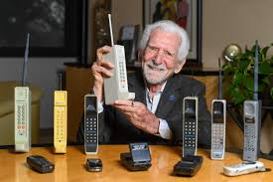However, the **first-ever smartphone** can be traced back to:

**1. IBM Simon Personal Communicator (1994)**

* **Founder**: The team at **IBM**.
* **Details**: Often considered the first true smartphone, the **IBM Simon** combined the functionality of a mobile phone and a PDA (personal digital assistant). It had a touchscreen, could send emails, and had applications like a calendar, contacts, and a world-time clock.

**2. Steve Jobs & the iPhone (2007)**

* **Founder**: **Steve Jobs** (Apple).
* **Details**: The iPhone, released in 2007, combined a phone, an iPod, and an internet communicator into one sleek device, revolutionizing the smartphone industry and setting the foundation for modern smartphones.

# What real world problem did they solve

OpenAI's ChatGPT addresses several real-world challenges faced by smartphone users and developers, enhancing productivity, accessibility, and user experience.

**1. Enhanced Smartphone Assistance**

OpenAI has introduced GPT-4o, an advanced AI model capable of understanding and generating audio, video, and still images. This development significantly improves smartphone assistants' capabilities, enabling features like prolonged visual conversations, live translations, and context-aware responses. While not yet a fully autonomous assistant, GPT-4o offers faster and more refined interactions, enhancing user experience on smartphones .[The Guardian+1The Hindu+1](https://www.theguardian.com/technology/article/2024/may/14/openai-gpt-4o-model-offers-promise-of-improved-smartphone-assistants?utm_source=chatgpt.com)

**2. Integration with Smartphone Ecosystems**

Companies like Nothing have integrated ChatGPT into their devices, allowing users to interact with the AI assistant through voice commands. For instance, Nothing's audio products, such as Ear 1 and Ear 2, now support ChatGPT via the Nothing X app, enabling features like pinch-to-speak for direct communication with the AI assistant .[The Hindu+1Wikipedia+1](https://www.thehindu.com/newsletter/newsletter-today-cache/todays-cache-openai-co-founder-departs-integration-of-nothing-audio-products-with-chatgpt-unveiling-openais-gpt-4o-capabilities/article68177963.ece?utm_source=chatgpt.com)

**3. Practical Applications for Developers**

ChatGPT has proven valuable for developers in real-world scenarios. For example, a user utilized ChatGPT to design a custom alert system for a cat door, employing a nano microcontroller and reed switch. This DIY project, guided by ChatGPT's suggestions, cost under $12 and addressed a specific household issue effectively .[OpenAI Community](https://community.openai.com/t/real-world-problem-solved-with-chatgpt-just-a-success-story/221540?utm_source=chatgpt.com)

**4. Multimodal Interaction Capabilities**

The latest ChatGPT features support multimodal interactions, allowing users to engage with the AI assistant through voice and image inputs. Users can now snap pictures of landmarks, ask questions, and receive informative responses, enhancing the AI's utility in everyday scenarios .[The Times of India](https://timesofindia.indiatimes.com/gadgets-news/openai-launches-new-chatgpt-feature-makes-a-joke-about-the-companys-chaos/articleshow/105416520.cms?utm_source=chatgpt.com)

In summary, ChatGPT addresses real-world problems by enhancing smartphone functionalities, integrating seamlessly into device ecosystems, assisting developers in creating practical solutions, and supporting multimodal interactions for a more intuitive user experience.

# What was the founder thought proses

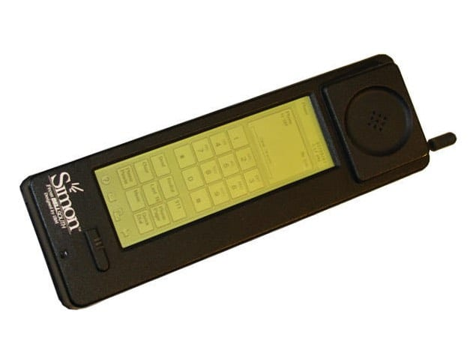

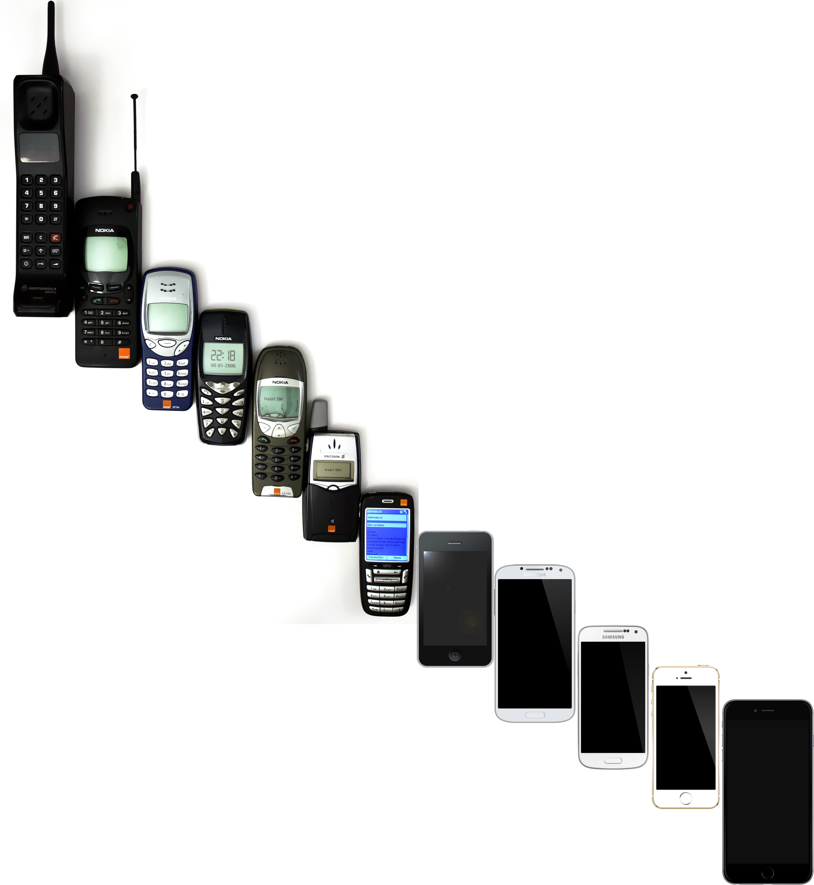

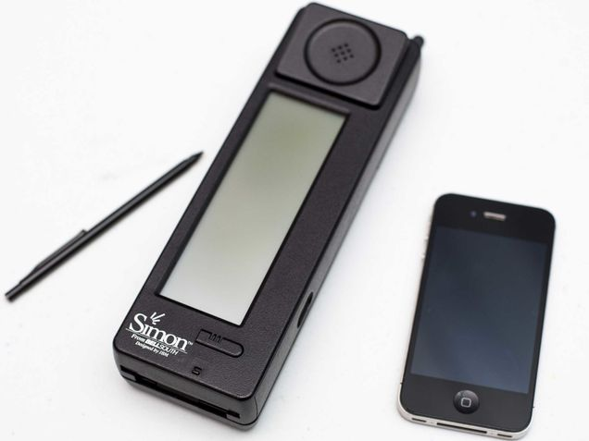

The development of the smartphone was driven by a convergence of technological advancements and visionary thinking aimed at enhancing communication and personal productivity.

**1. IBM Simon: The First Smartphone**

In 1992, IBM engineer Frank J. Canova recognized that miniaturized chip-and-wireless technology had advanced sufficiently to create a handheld device combining telephony and computing functions. This insight led to the development of the IBM Simon Personal Communicator, introduced in 1994. The device integrated features such as a calendar, address book, email, and fax capabilities, marking it as the first commercially available smartphone .[Wikipedia+2Wikipedia+2Wikipedia+2](https://en.wikipedia.org/wiki/Smartphone?utm_source=chatgpt.com)[Wikipedia+1Wikipedia+1](https://en.wikipedia.org/wiki/IBM_Simon?utm_source=chatgpt.com)

**2. Apple's iPhone: A Revolutionary Leap**

In the mid-2000s, Apple, under the leadership of Steve Jobs, aimed to redefine the mobile phone experience. Jobs envisioned a device that eliminated the need for a stylus, opting instead for a capacitive multi-touch screen that users could interact with directly using their fingers. This vision culminated in the launch of the first iPhone in 2007, which combined a phone, iPod, and internet communicator into a single device. The iPhone's introduction revolutionized the smartphone industry, setting new standards for mobile computing .[Wikipedia](https://en.wikipedia.org/wiki/IPhone_%281st_generation%29?utm_source=chatgpt.com" \t "_blank)[Time](https://time.com/4837176/iphone-10th-anniversary/?utm_source=chatgpt.com)

**3. Evolution of Smartphone Design**

The evolution of smartphones has been characterized by continuous innovation in design and functionality. Early devices were primarily focused on communication, but over time, smartphones have incorporated features such as high-resolution cameras, advanced processors, and a wide array of applications, transforming them into essential tools for various aspects of daily life.

In summary, the development of the smartphone was driven by a combination of technological advancements and visionary thinking, leading to devices that have become integral to modern communication and productivity.

# how did they start(plan,tools,research)?

**🧠 Vision and Planning**

In 1992, IBM engineer Frank Canova envisioned a device that could integrate the functionalities of a mobile phone with those of a personal digital assistant (PDA). This concept aimed to create a "computer that could fit in your shirt pocket," addressing the growing need for mobile communication and personal organization tools .[Mobile Phone Museum+2Mobile Phone Museum+2simoneer.github.io+2Mobile Phone Museum+1Mobile Phone Museum+1](https://www.mobilephonemuseum.com/phone-detail/ibm-simon?utm_source=chatgpt.com)

**🛠️ Tools and Technology**

* **Hardware Components**: The Simon utilized a touchscreen interface, a stylus for input, and a cellular radio module sourced from Motorola's flip phones.[nextgencomms.com+2Mobile Phone Museum+2LinkedIn+2](https://www.mobilephonemuseum.com/phone-detail/ibm-simon?utm_source=chatgpt.com)
* **Software Development**: The device's operating system was built on a customized version of the PC/GEOS platform, enabling functionalities like email, calendar, and fax.
* **Prototyping**: A prototype, code-named "Sweetspot," was developed and showcased at the Comdex trade show in 1992, demonstrating the feasibility of the concept .[Mobile Phone Museum](https://www.mobilephonemuseum.com/phone-detail/ibm-simon?utm_source=chatgpt.com)

**🔍 Research and Collaboration**

* **Market Research**: IBM identified a gap in the market for a device that combined mobile communication with personal organization tools, leading to the conceptualization of the Simon.[simoneer.github.io](https://simoneer.github.io/history/?utm_source=chatgpt.com)
* **Partnerships**: IBM collaborated with BellSouth Cellular Corp. for distribution in the United States, and Mitsubishi Electric for manufacturing the device.[Bloomberg+3Wikipedia+3YouTube+3](https://en.wikipedia.org/wiki/IBM_Simon?utm_source=chatgpt.com)
* **User Feedback**: Early user testing and feedback were integral in refining the device's features and user interface.

**🚀 Execution and Launch**

* **Development Timeline**: The project progressed from concept to prototype within a few months, with the first public demonstration occurring at Comdex in November 1992.[simoneer.github.io+1Mobile Phone Museum+1](https://simoneer.github.io/history/?utm_source=chatgpt.com)
* **Commercial Release**: The IBM Simon was released in August 1994, priced at $1,099, and sold approximately 50,000 units during its six-month availability .[Mobile Phone Museum+3Textline+3Time+3](https://www.textline.com/blog/smartphone-history?utm_source=chatgpt.com)

The development of the IBM Simon was a groundbreaking effort that laid the foundation for modern smartphones, combining innovative thinking with strategic planning and collaboration.

# What makes their solution creative?

**🔍 Key Innovations**

1. **Touchscreen Interface**: The Simon featured a 4.5-inch monochrome LCD touchscreen, allowing users to interact directly with the device, a novel concept at the time.[AndroidAyuda+2odotonline.org+2MobilesTalk+2](https://www.odotonline.org/this-was-ibm-simon-the-first-smartphone-born-in-the-early-90s/?utm_source=chatgpt.com)
2. **Integrated Applications**: It came preloaded with applications such as an address book, calendar, email client, fax capabilities, notepad, and sketch pad, enabling users to manage personal and professional tasks on a single device.
3. **Stylus Input**: The inclusion of a stylus allowed users to write or draw on the screen, facilitating note-taking and sketching, which could then be sent via fax.[MobilesTalk+4RR Auction+4RR Auction+4](https://www.rrauction.com/auctions/lot-detail/349355607146289-ibm-simon-personal-communicator-the-first-true-smartphone/?utm_source=chatgpt.com)
4. **Predictive Text Technology**: The Simon introduced a predictive keyboard that anticipated the next letter a user intended to type, streamlining text input on the touchscreen.[RR Auction+1RR Auction+1](https://www.rrauction.com/auctions/lot-detail/349355607146289-ibm-simon-personal-communicator-the-first-true-smartphone/?utm_source=chatgpt.com)
5. **Modular Expandability**: It featured a PCMCIA slot, enabling users to expand the device's functionality with additional modules, such as a paging card.[RR Auction+3Mobile Phone Museum+3RR Auction+3](https://www.mobilephonemuseum.com/phone-detail/ibm-simon?utm_source=chatgpt.com)

These features collectively represented a significant leap in mobile technology, combining communication, organization, and productivity tools into a single portable device.

For a more in-depth exploration of the IBM Simon and its impact, you might find this video informative:

[Life Before iPhone - First there was Simon](https://www.youtube.com/watch?v=8lSVf8iXxrk)

# What inspired or surprised you the most

**💡 Vision and Inspiration**

In the early 1990s, IBM engineer Frank Canova recognized the potential of combining mobile phone technology with personal digital assistant (PDA) features. This insight led to the creation of a prototype device, code-named "Sweetspot," which integrated functionalities such as a calendar, address book, and email capabilities into a single handheld device .[Wikipedia](https://en.wikipedia.org/wiki/IBM_Simon?utm_source=chatgpt.com)

**🛠️ Development and Tools**

The development team utilized advances in metal–oxide–semiconductor field-effect transistor (MOSFET) technology, enabling the creation of smaller integrated circuit chips suitable for handheld devices . The prototype was demonstrated at the COMDEX trade show in Las Vegas in 1992, garnering significant attention and interest from the tech community .[Time+2Wikipedia+2History Tools+2](https://en.wikipedia.org/wiki/IBM_Simon?utm_source=chatgpt.com)

**📱 Surprises and Challenges**

One of the most surprising aspects of the Simon was its early adoption of a touchscreen interface, allowing users to interact with the device in a manner that was ahead of its time. Despite its innovative features, the device faced challenges such as limited battery life and a bulky design, which impacted its commercial success .[Indiatimes](https://www.indiatimes.com/technology/news/25-years-ago-ibm-launched-simon-world-s-1st-smartphone-that-forever-changed-what-phones-meant-373716.html?utm_source=chatgpt.com)

**🌟 Legacy**

Although the IBM Simon was discontinued after a short period, its influence on the development of future smartphones is undeniable. It laid the groundwork for the integration of communication and computing functionalities in mobile devices, inspiring subsequent innovations in the smartphone industry .[History Tools](https://www.historytools.org/products/simon-personal-communicator?utm_source=chatgpt.com)

In summary, the creation of the IBM Simon Personal Communicator was a groundbreaking endeavor that combined visionary thinking with technological innovation, setting the stage for the development of modern smartphones.

# What you learn about innovation?

**🔍 Key Lessons from the IBM Simon Innovation**

**1. Visionary Thinking Drives Innovation**

Frank Canova's vision to integrate a mobile phone with personal digital assistant (PDA) functionalities was groundbreaking. This foresight led to the creation of a device that combined communication and computing in a portable form, laying the foundation for modern smartphones.

**2. Timing Is Crucial**

Despite its innovative features, the IBM Simon faced challenges due to its premature introduction. The lack of widespread mobile internet, limited battery life, and high cost hindered its adoption. This underscores the importance of aligning technological advancements with market readiness. [BBC+1The Waves+1](https://www.bbc.com/news/technology-28802053?utm_source=chatgpt.com)[The Waves](https://www.the-waves.org/2021/12/24/smartphone-invention-rise-of-a-disruptive-innovation-force/?utm_source=chatgpt.com)

**3. User-Centric Design Is Essential**

The Simon's touchscreen interface and inclusion of applications like email and a calendar were ahead of their time. However, its bulky design and limited battery life impacted user experience. This highlights the need for balancing innovation with practicality in product design. [Fast Company+3Time+3simoneer.github.io+3](https://time.com/3137005/first-smartphone-ibm-simon/?utm_source=chatgpt.com)

**4. Iterative Development Leads to Success**

The Simon's discontinuation after a short market presence illustrates that initial failures can provide valuable lessons. Subsequent iterations and refinements, as seen in later smartphone developments, are crucial for long-term success. [Fast Company](https://www.fastcompany.com/91140250/how-ibm-invented-the-smartphone-then-abandoned-it?utm_source=chatgpt.com)

**🌐 Broader Implications for Innovation**

The IBM Simon's journey emphasizes that innovation is not solely about introducing new technologies but also about understanding and anticipating user needs, market conditions, and technological ecosystems. It teaches that successful innovation requires a harmonious blend of vision, timing, user-centric design, and adaptability.

# What surprised you bout how simple ideas because big teach

**💡 The Genesis of the Idea**

IBM engineer Frank Canova envisioned a device that combined the communication capabilities of a mobile phone with the organizational tools of a PDA. This concept was inspired by the desire to create a portable device that could handle calls, emails, calendars, and more, all in one. The simplicity of this idea laid the foundation for what would become the first smartphone.

**🛠️ From Concept to Creation**

The development process involved overcoming significant technical challenges. IBM utilized advances in MOSFET (metal–oxide–semiconductor field-effect transistor) technology, which enabled the creation of smaller integrated circuit chips suitable for handheld devices . The prototype, code-named "Sweetspot," was showcased at the COMDEX trade show in 1992, demonstrating the feasibility of combining a mobile phone with PDA features.[Wikipedia](https://en.wikipedia.org/wiki/IBM_Simon?utm_source=chatgpt.com)

**📱 The Impact of a Simple Idea**

Despite its innovative features, the IBM Simon faced challenges such as limited battery life and a bulky design, leading to its discontinuation after a short period. However, its influence on the smartphone industry is undeniable. It introduced concepts like touchscreens, email capabilities, and personal organization tools into mobile devices, setting the stage for the development of modern smartphones .[Scribd+1News Track Live+1](https://www.scribd.com/document/698212451/Creative-Design-and-Innovation-How-to-Produce-Successful-Products-and-Buildings-by-Robin-Roy?utm_source=chatgpt.com)[News Track Live](https://english.newstracklive.com/news/the-evolution-of-smartphones-unveiling-the-ibm-simon-the-pioneer-of-mobile-technology-emc-sc71-nu384-ta384-1284708-1.html?utm_source=chatgpt.com)

**🌱 Lessons Learned**

The journey of the IBM Simon underscores the power of simple ideas in driving innovation. It highlights the importance of vision, collaboration, and perseverance in transforming concepts into impactful technologies. Moreover, it teaches that even if an innovation doesn't achieve immediate commercial success, its influence can resonate and inspire future advancements.

In essence, the IBM Simon Personal Communicator exemplifies how a straightforward idea, when executed with creativity and determination, can lead to significant technological breakthroughs.

# Impact on people’s life by the innovation

**📱 Transforming Communication**

Smartphones have revolutionized how we connect with others. Beyond voice calls, they facilitate instant messaging, video calls, and social media interactions, enabling real-time communication across the globe. This constant connectivity has redefined personal and professional relationships, making it easier to maintain connections regardless of distance.[Saberpoint+1Daily Trust+1](https://saberpoint.com/how-smartphones-have-changed-the-way-we-work/?utm_source=chatgpt.com)

**🧠 Enhancing Productivity and Learning**

With the advent of smartphones, individuals can manage tasks, set reminders, and access a plethora of productivity tools on the go. Educational apps and resources have democratized learning, allowing users to acquire new skills and knowledge at their own pace. This accessibility has empowered individuals to pursue continuous learning and personal development.

**🛍️ Revolutionizing Commerce**

E-commerce has flourished with the proliferation of smartphones. Consumers can shop online, compare prices, and make purchases from the comfort of their homes. Mobile banking and payment apps have simplified financial transactions, making managing finances more convenient and secure.[Daily Trust](https://dailytrust.com/how-have-smartphones-changed-the-way-we-live/?utm_source=chatgpt.com)

**🎮 Redefining Entertainment**

Smartphones serve as portable entertainment hubs, offering access to streaming services, music, games, and social media platforms. This accessibility has transformed how we consume media, allowing for personalized and on-demand entertainment experiences.[Looklify](https://www.looklify.com/how-smartphones-transformed-the-world/?utm_source=chatgpt.com)

**🏥 Advancing Health and Wellness**

Health and fitness apps have empowered individuals to monitor their physical activity, diet, and overall well-being. Telemedicine services have made healthcare more accessible, enabling consultations with medical professionals remotely. These advancements have contributed to a more health-conscious society.

**🌐 Bridging Global Gaps**

In regions with limited access to traditional infrastructure, smartphones have provided a means to access information, education, and services. They have become tools for empowerment, offering opportunities for individuals to improve their circumstances and connect with the broader world.[Newsoftwares.net+3The Australian+3Wikipedia+3](https://www.theaustralian.com.au/inquirer/the-great-dumbing-down-is-having-serious-realworld-consequences/news-story/e023bb99ec5a4fb26b13982d60f44cb7?utm_source=chatgpt.com)

In essence, the evolution from the IBM Simon to today's smartphones illustrates how a simple idea can catalyze widespread change. These devices have become integral to modern life, influencing how we communicate, learn, work, and entertain ourselves.